June 1:
Breakfast/Snack Banana Split

Ingredients
1 bananas
1/2 cup cottage cheese 1% or fat free (or Greek yogurt)
2 Tbsp. all- fruit strawberry jam
5-7 strawberries sliced
5-7 blackberries
1 teaspoon granola or toasted oats
1 teaspoon chopped nuts like almonds, peanuts, or cashews

Instructions
Peel 1 bananas and cut in half lengthwise. Place banana halves in a shallow bowl . Add a few berries to the bottom of the bowl, between banana slices. Top with cottage cheese and sprinkle with remaining berries, granola and chopped nuts. Repeat with remaining banana, to prepare second banana split. Serve immediately.
for a little extra sweetness drizzle with honey or agave

Recipe adapted from simplehealthykitchen.com

June 2
Water Hose Games:
- Tag
- Limbo
- Mud Castles- Think sand castles, but work with what you’ve got!
- Sprinkler Fun- No sprinkler attachment? Hold your thumb over the hose and make it spray!

June 3
Paper Airplane Activities:
Fun & Educational STEM Paper Airplane Challenge | Kids Activities Blog

June 4
Board Game Fun:
Everyone chooses one board game to play! Enjoy the evening with some friendly, fun challenge!

June 5
Animal Yoga:
Cosmic Kids Yoga - YouTube

June 6
Notes of Kindness:
Write random notes of kindness. Choose a neighbor, someone you see at the store every day, a family member, a friend! Write a note of kindness and deliver it.

June 7
Relay Games & Obstacle Courses:
Fun and Simple Relay Races for Kids - ONE SIMPLE PARTY

Brainstorm an obstacle course for the backyard. Grab paper and pen, and dream up what you can make possible. Gather supplies and get started! Have fun with it!

June 8
No Bake Energy Balls
Ingredients
1 cup old fashioned rolled oats
1/2 cup natural peanut butter
1/4 cup honey
1/4 cup unsweetened shredded coconut
1/4 cup chocolate chips
1 teaspoon vanilla extract
pinch of sea salt

Instructions
Mix all ingredients in a bowl. Roll in to 1 inch balls and enjoy!

Recipe adapted from eatingbirdfood.com

June 9
Super Soaker Sponge Fun:
How to Make Super Soaker Sponge Balls Kids Will Love - Natural Beach Living

June 10
Salt Dough Fossils:
How to Make Salt Dough Dinosaur Fossils | Mombrite
Lesson: Fun with Fossils | PBS LearningMedia

June 11
Nature Scavenger Hunt:
Nature Scavenger Hunt - Printable – Therm

June 12
Family Spa Day:
Face Masks- Face Masks for Kids: 5 Simple and Quick Recipes • The Koala Mom
Kids Spa Day on a Dollar Store Budget (schooloftoughmoms.com)
Bath Bombs- How to Make Bath Bombs for Kids: An Easy Bath Bomb Recipe | Creative Green Living

June 13
Trash Pick Up Day:
Choose a place, grab some gloves, and pick trash up with the family! Watch for sharp objects and let the adults pick decide what is safe to pick up and what is not.

June 14
Dance Party
Everyone choose their favorite song and play it loud! Show off your BEST dance moves. Record the dance party so you can all enjoy it later!

June 15
Peanut Butter Cheerio Bars

Ingredients
3 cups Cheerios cereal
1/2 cup peanut butter
1/2 cup honey

Instructions
Line an 8x8in pan with parchment paper.
Combine peanut butter and honey in a large saucepan and set over medium heat.
Heat until mixture just starts to simmer, about 2-3 minutes, stirring.
Remove from heat and stir until mixture is smooth.
Stir in cereal until evenly coated.
Pour mixture into prepared pan and spread evenly.
Chill in the refrigerator for 1 hour.
Cut into bars.

Recipe adapted from thelazydish.com

June 16
Splash Pad Fun
Find a Splash Pad or Water Play space near your area and enjoy the day!

June 17
Build a Raft STEM activity
What can you build a raft out of? Grab some supplies and start building!
Plastic straws, popsicle sticks, sticks from the yard- it’s all fair game.
How much weight can your raft carry? How many pennies? How many quarters? How many rocks?
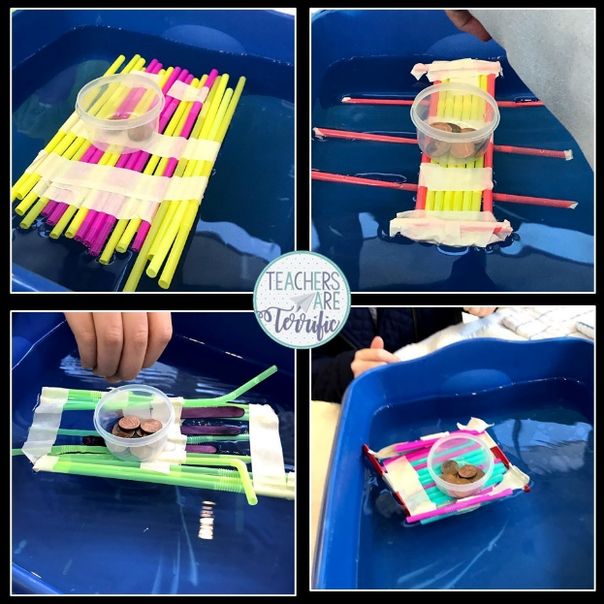

June 18
Backyard Campsite
Set up a tent, or build a blanket fort outside! Gather sticks and rocks for your make believe campfire (or build a real one with an adult!). Go on a bear hunt, go fishing- your imagination can take you all kinds of places. Take a picture of your creation and share with us!
Facebook or e-mail!

June 19
Family Vision Board
How to Create a Family Vision Board (gloverhealth.com)

June 20
Choose a family to cook a meal for!
Try these great meals that will feed a family of 4 for less than $10.
Recipes | Cooking Matters

June 21
Sidewalk Chalk Activity Course
https://youtu.be/YqrTCcFbtVs

June 22
Berry Granola Yogurt Bark

Ingredients
3 cups mixed berries, fresh or frozen, separated
2 cups plain yogurt (see notes)
2-3 tbsp honey
1/2 cup granola

Instructions
Line a baking sheet with parchment paper. You can use a 9x9 baking dish, 9x13 baking dish or a 13x18 baking sheet, depending on how thick you want your bark.
In a blender, add in 2 cups of the berries, the yogurt and honey and blend until smooth.
Pour the yogurt onto the baking sheet and spread with a knife or spatula until you have a smooth layer.
Sprinkle on the remaining chopped berries and granola. Place the baking sheet in the freezer for at least 4 hours.
Take the baking sheet out of the fridge and break the yogurt bark into chunks with your hands.
Serve and enjoy.

Recipe adapted from babyfoode.com

June 23
Wash the Car together!
Pull out the water hose, soap, and sponges and have some fun! Go for a fun water fight afterwards to finish the day off right!

June 24
STEM Tower Challenge
Grab some plastic cups and popsicle sticks and start building! See who can create the tallest tower! Make it a family challenge. Who will win?

June 25
Pack a Picnic & Choose a Park
Make a list of all the parks in your area. Write them on slips of paper, drop them in a cup, and draw for the winner!
Pack a picnic and make a day of it.

June 26
Cloud Animals Hunt
Grab a blanket, find a grassy spot, and lay down to look at the clouds. See how many different animals you can find! Make it more fun by making a list of all your favorite animals. Don’t leave your spot until you find the animals! Enjoy the weather and the quiet time searching for the animals.

June 27
Make Cards & Deliver to Patients
Make cards & deliver them to your local nursing homes, hospitals, or food shelters.

June 28
Walking Trail Activities
Scooters, bikes, walking, running- it’s all fair game. Just get moving together!

June 29
Chocolate dipped waffle cone fruit and yogurt cups

Ingredients
8 Waffle Cones
Milk Chocolate Melting Wafers
Short Cups for holding the cones
Vanilla Yogurt
Berries of Choice

Instructions
Melt the chocolate in a large measuring cup or deep cereal bowl.
Dip the mouth of each waffle cone in chocolate and place in a short cup to keep the chocolate from touching anything.
Place the cups on a cookie sheet so you can lift the whole thing into the fridge to set the chocolate.
Fill each cone with yogurt and berries and serve up!
Notes
You can refrigerate for up to 3 days.

Recipe taken from ohsweetbasil.com

June 30
Water Balloons & Sprinkler Fun
Water Balloon Fight! Fill up the balloons, hook up the sprinkler, and get started! The fight is on!

